We are introducing 5 new improvements to help us manage our paper-flow and budget better. This document contains Templates, and instructions to help you adopt the new process. Additionally, we will host weekly conference calls where you may call in and get coaching on how to prepare your files to ensure prompt processing.

- e-Process – EVERYTHING is Electronic
- All reqs and invoices must be scanned or saved as PDFs (save as pdf)
- Backup documentation must be attached to reqs/invoices in one single pdf file (combine)
- Approvers must eSign the reqs/invoices based on approval thresholds (esign)

(if you do not have Adobe Acrobat, please send all associated documents to the correct approver – they should be able to combine them all prior to e-signing).

- COVER SHEETS
- All reqs and invoices must have a cover sheet.

- Req Cover sheet is here:
(double click to open
save locally to use)

Invoice Cover sheet is here:
(double click to open
save locally to use)

- These coversheets must be:
  - Cover sheets should be descriptive enough to stand on their own and explain the request to a person with no knowledge of facilities management or construction.
  - saved as pdfs,
  - attached to backup documentation,
  - e-signed by the correct approver, and
  - submitted electronically.

- NEW FILE NAMING CONVENTION
To help us track files and process requests faster, we ask that you please follow these new naming rules for all your submittals:

- ALWAYS NAME REQs: vendor name-location-brief description-dollar amount.pdf
Example: Arden-Pastore-DMV-Window-Clean-$1000.00.pdf

- ALWAYS NAME INVOICES: vendor name-invoice no-po #-dollar amount.pdf
Example: Arden-Invoice#124-PO#1256976-$980.62.pdf

- NEW APPROVAL THRESHOLDS TO STREAMLINE PROCESSING
For faster processing of requests, we are instituting the following thresholds.

DOLLAR VALUE APPROVER SECOND APPROVER
$0 - $10,000 Deputy CPM, PM2, IPM na
$10,001 - $50000 CPM, Deputy Director na
$50,001 - $100,000 Ch.Eng, Tom N, John M, John R, Sagree S na
$100,000 + Marco S, Tom N, John M, John R, Sagree S Carole C
CPM: Chief Property Manager: AJ, MB, JT, DB, SD
PM2: Project Manager II (or similar): CH, LL, MP, JC, KR,
IPM: Interdepartmental Project Manager: CB, SF
Ch. Eng: Chief Engineer: DK, DM
Dep.CPM: KO, EB, TD, CH
Dep.Dir: JR
(Please note that these same thresholds will be carried over to Ocean State Procures upon its launch so while the mechanism of processing requests might change, the limits and responsibilities on you as project managers and approvers will remain the same.)

- NO MORE EMAILING REQs and INVOICES for PROCESSING
Within DCAMM, we are recommending that everyone use the ‘task-assignment’ feature in outlook to share documents with approvers for their signatures. Directions on using the task-assignment features are included at the end of this document.
Once a document is approved, the file can be directly uploaded to the J drive for processing. In 2 simple steps this can be done easily:
- Approvers upload signed reqs to J:\CBO-DCAMM\DCAMM Inbox\Reqs
- Approvers upload signed invoices to J:\CBO-DCAMM\DCAMM Inbox\Invoices
- After submitting documents to the correct folder, Approvers must log the entry into the spreadsheet titled “TRACKING” found at J:\CBO-DCAMM\DCAMM Inbox
DCAMM Budget group will review all submittals at 2pm each business day and assign account/payment information as applicable. Where information is missing, we will move it to ‘missing information’ folder at J:\CBO-DCAMM\DCAMM Inbox\Missing Information and inform the approver. If the documents are complete and correct, we will assign the appropriate account number, record the expense for our tracking, and forward on to CBO with our approval to process. Our target is to have no more than 1-2 business days between receiving paperwork and forwarding it to CBO.
Weekly conference calls will be conducted starting Tuesday May 5th at 3pm to help troubleshoot this process and to address any questions or doubts you may have. Call in number is (605) 313-5684 (Access Code: 658841) – We will conduct these calls every Tuesday for the foreseeable future until attendance drops to zero.
TASK ASSIGNMENT in OUTLOOK:
- Create a NEW TASK
  - Select ASSIGN TASK to your supervisor or approver of requisitions/invoices
  - If the item is of high importance, click HIGH IMPORTANCE. NOTE: Not everything can be high importance.
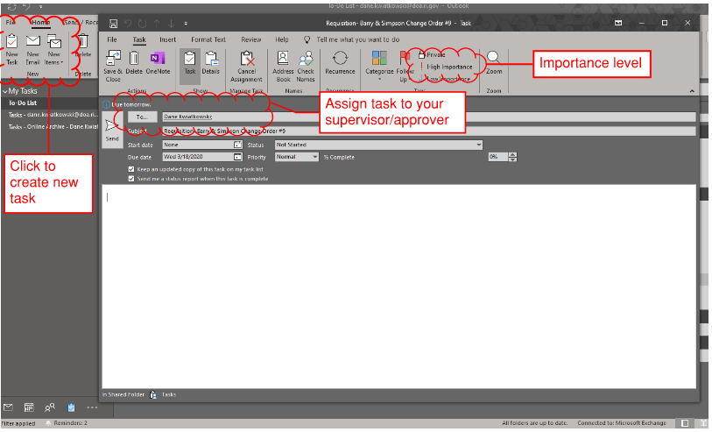
- Attach your document(s)
  - Use the drag and drop feature or INSERT, then ATTACH FILE, and select the appropriate documents. Your task should look something like this:
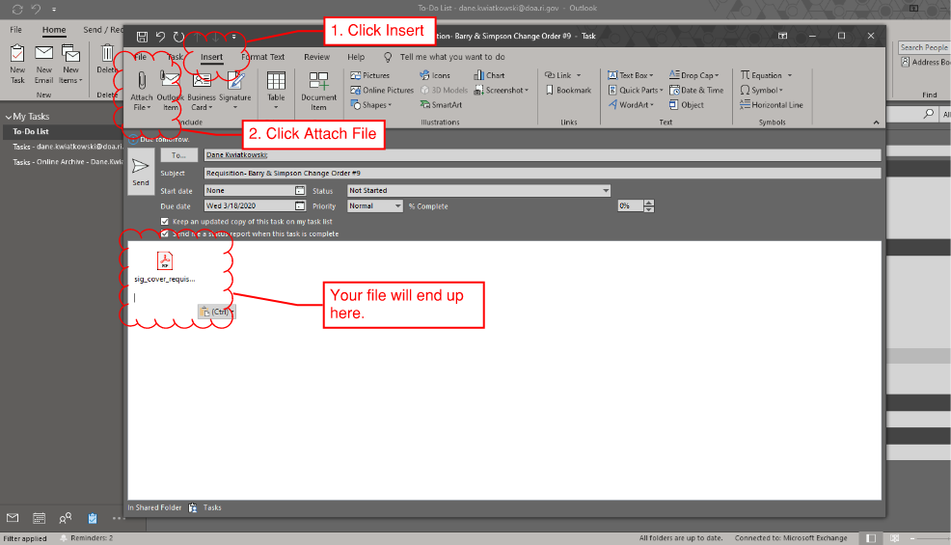

- SEND to your approver

- APPROVERS- Open the file with Adobe, Bluebeam, or similar editing program. Sign electronically (IF CAPABILITY EXISTS) and save the file in the appropriate folder in the shared drive J:\CBO-DCAMM\DCAMM Inbox.
